Pupil premium strategy statement – Mowmacre Hill Primary school 2023.24 review
Before completing this template, read the Education Endowment Foundation’s guidance on using your pupil premium funding effectively and DfE’s using pupil premium guidance, which includes the ‘menu of approaches’. It is for school leaders to decide what activity to spend their pupil premium (and recovery premium) on, within the framework set out by the menu.
All schools that receive pupil premium (and recovery premium) are required to use this template to complete and publish a pupil premium statement on their school website by 31 December every academic year.
If you are starting a new pupil premium strategy plan, use this blank template. If you are continuing a strategy plan from last academic year, you may prefer to edit your existing statement.

Before publishing your completed statement, delete the instructions (text in italics) in this template, including this text box.

This statement details our school’s use of pupil premium (and recovery premium) funding to help improve the attainment of our disadvantaged pupils.
It outlines our pupil premium strategy, how we intend to spend the funding in this academic year and the outcomes for disadvantaged pupils last academic year.

School overview (22.23)
Detail | Data
Number of pupils in school | Mowmacre Hill Primary School
Proportion (%) of pupil premium eligible pupils | 51.5%
Academic year/years that our current pupil premium strategy plan covers (3 year plans are recommended) | 2021/2022 – 2023/2024
Date this statement was published | December 2021 (1st version)  October 2023 (this review)
Date on which it will be reviewed | Sept 2024
Statement authorised by | Matthew Peet  Head Teacher
Pupil premium lead | Annemarie Timmins
Governor / Trustee lead | Jackie Dean

Funding overview
Detail | Amount
Pupil premium funding allocation this academic year | £263,847
Recovery premium funding allocation this academic year | £26,535
Pupil premium (and recovery premium*) funding carried forward from previous years (enter £0 if not applicable)  *Recovery premium received in academic year 2021 to 2022 can be carried forward to academic year 2022 to 2023. Recovery premium received in academic year 2022 to 2023 cannot be carried forward to 2023 to 2024. | £8,886
Total budget for this academic year  If your school is an academy in a trust that pools this funding, state the amount available to your school this academic year | £299,268

Part A: Pupil premium strategy plan

Statement of intent
Our intention is that all pupils at Mowmacre Hill Primary School, irrespective of their background, COVID19 or any challenges they face, make good progress and achieve high attainment across all subject areas. The overall aim of our pupil premium strategy is to provide support disadvantaged pupils to achieve that goal. This also includes pupils being challenged further and enhancing their progress for those who are already high attainers.
We ensure that high-quality teaching is at the core of our approach. We also focus on areas in which disadvantaged pupils require the most support. It is evident that this will have the greatest impact on closing the disadvantage attainment gap. At Mowmacre Hill we believe that at the same time will benefit the non-disadvantaged pupils in our school. Alongside our intended outcomes that are detailed below, it is the intention that non-disadvantaged pupils’ attainment will be sustained and improved alongside progress for their disadvantaged peers.
We will carefully consider the challenges that our pupils may face, such as those who require support with well-being and attendance or if they may be a young carer or supported by social services. The approaches we intend to implement which we have highlighted within this statement is also intended to support their needs, regardless of whether a child is disadvantaged or not.
Our strategy is integral to wider school plans for education recovery. Our approach will be in response to common challenges that have arisen and to individual needs. This holistic approach will be evidenced through continuous assessment and not based upon the assumptions about the impact of disadvantage. The approaches we have decided to embed, will complement each other to support all pupils excel. To ensure they are effective we will:
- ensure disadvantaged pupils are challenged in their work
- act promptly when an area of need has been identified.
adopt a whole school approach in which all staff take responsibility for disadvantaged pupils’ outcomes and raise expectations of what they can achieve

Challenges
This details the key challenges to achievement that we have identified among our disadvantaged pupils.
Challenge number | Detail of challenge
1 | Internal assessments indicate that the writing attainment for 2020/2021 Summer 2 data among disadvantaged pupils is significantly below non-disadvantaged pupils (disadvantage pupils ARE 35%). 52% of children in year 6 that were recognised as disadvantaged reached ARE in writing by the end of the academic year. Year 2 data identifies that 8% of children who are disadvantaged achieved the expected standard by Summer 2.  On entry to reception in September 2021, 90% of the cohort arrived below age related expectations.
2 | Improving Speech and language across the whole of the school  Assessment, discussions and observations with pupils across both key stages indicate underdeveloped oral language skills and vocabulary gaps. This is evident from receptions screening data 0% of children presented as achieving expected expressive and receptive language.
3 | Some pupils lack real world experiences to build knowledge, social skills land resilience. Research from the IDACI suggests that the Mowmacre Hill is in the top 3% of deprived areas in the country.
4 | Assessment and observations indicate that the education and well-being of many of our disadvantaged pupils has been impacted by the partial closure of schools.  These children are in need of support to ensure good mental health and well-being. In school this could manifest itself as anxious, withdrawn or disruptive behaviour in class. This has resulted in significant knowledge gaps across the curriculum.
5 | Due to Covid-19 we have seen a huge increase in the need and support of the family support worker. There were 317 Child protection incidents recorded using Cpoms and there has also been an increased referral and support through the schools’ early help offer due to circumstances changing. To support families’ food parcels (72 in the last 12 months) have been supplied through the family support officer and also the requirement of support relating to mental health and domestic abuse.
6 | Improve attendance for children that are eligible for pupil premium. Pupil premium attendance has increased slightly from 89.8% in 2019/2020 to 92.9% in 2020/2021. This still is well below government expectations of 96%.

Intended outcomes
This explains the outcomes we are aiming for by the end of our current strategy plan, and how we will measure whether they have been achieved.
Intended outcome | Success criteria
Improve writing attainment for children across the school. | PP Pupils to receive extra support with reading and writing to help towards end of Key stage outcomes. Key stage 2 writing outcomes in 24/25, show that more than 65% disadvantaged pupils will meet the expected standard.
Children across the school to access Speech and Language Therapy. | Assessments and observations indicate significantly improved oral language among disadvantaged pupils. This is evident when triangulated with other sources of evidence, including engagement in lessons, book scrutiny and ongoing formative assessment.
Providing real life experiences for children who are eligible for pupil premium. | Children will receive partial financial support towards real world experiences.
Children who need support with Social, Emotional and Mental Health needs will receive support. | Children will receive targeted support by accessing ELSA, inclusion champion or the Family Welfare Officer. Pupils to show an improved metal wellbeing through support for SEHM needs.  Sustained high levels of wellbeing from 2024/25 demonstrated by:  - qualitative data from student voice, student and parent surveys and teacher observations
Improve attendance for children that are eligible for pupil premium. | Sustain attendance from 2024/25 demonstrated by:  - the average percentage of all children attending to be above 96%  - the percentage of disadvantaged pupils who are persistently absent being below 20%

Activity in this academic year (2023.24)
This details how we intend to spend our pupil premium (and recovery premium) funding this academic year to address the challenges listed above.

Teaching (for example, CPD, recruitment and retention)
Budgeted cost: £ 42,030
Activity | Evidence that supports this approach | Challenge number(s) addressed
Teacher development release time – each teacher released for 2 hours per week for coaching and development | EEF – mastery learning + 5 months - Metacognition + 7 months  https://educationendowmentfoundation.org.uk/educationevidence/teaching-learning-toolkit/masterylearninghttps://educationendowmentfoundation.org.uk/educati on-evidence/teaching-learning-toolkit/mastery-learning  https://educationendowmentfoundation.org.uk/educationevidence/teaching-learning-toolkit/metacognition-and-selfregulation | 1-6  £34,030
Recovery resources | Mowmacre Has invested in buying an amount of Laptops to ensure that every child has the best opportunities and equity amongst their peers.  https://d2tic4wvo1iusb.cloudfront.net/production/eef-guidance-reports/literacy-ks2/EEF-Improving-literacy-in-key-stage-2-report-Second-edition.pdf?v=1699330532 | 1 and 3  £9,000

Targeted academic support (for example, tutoring, one-to-one support, structured interventions)
Budgeted cost: £104,330
Activity | Evidence that supports this approach | Challenge number(s) addressed
National Tutoring Programme  24 PP children, 2 hours a week for 32 weeks, 8 members of staff (4 each hour) | The EEF Teaching and Learning Toolkit indicates “that if tuition is high-quality and aligned to classroom teaching, pupils can make up to five months additional progress with one-to-one tuition and up to four months additional progress with small group tuition” (taken from the EEF Making a Difference with Effective Tutoring guide)  “Tuition is one of the best evidenced interventions we have to support disadvantaged pupils’ attainment.”  - Professor Becky Francis | 1  £10,800
Speech and language Therapist to work with identified children to support their level of communication. This support is delivered frequently to ensure that a maximum level of progress is achieved.  SALT are also providing training for teachers and support staff to broaden skill set. | The Communication Trust: “There is a substantial amount of evidence linking SLCN with other areas of difficulty. We know that children with SLCN have difficulties across many areas of their lives.”  “On average, oral language approaches have a high impact on pupil outcomes of 6 months’ additional progress.” – EEF Oral Language Interventions findings  School baseline data against the communication trust age-appropriate expectations shows that large proportion of children are below.  Epic provide regular discussion with colleagues and to discuss SALT interventions. This gives an opportunity to discuss any concerns and any areas that need to be addressed. Epic also provide training to staff in order for the interventions that Epic run to be conducted by TAs throughout the week. Most interventions are usually three times a week; one session ran by Epic and the others by TAs. This is regularly assessed by EPIC and feedback forms are completed by TAs each session. | 2  £34,214 (SALT)  EPIC AND SALT
Children that require support from one of the ELSA’s are identified by staff. Interventions are then designed to support the children’s needs. | Behaviour intervention Sutton Trust: moderate impact for moderate cost (social and emotional learning)  “Social and emotional learning approaches have a positive impact, on average, of 4 months’ additional progress in academic outcomes over the course of an academic year…being able to effectively manage emotions will be beneficial to children and young people even if it does not translate to reading or maths scores…” – EEF Social and Emotional Learning findings  The ELSAs provide sessions that are tailored to meet the needs of each pupil. Interventions are running on a 1:1 basis or in a group. They conduct weekly well-being meetings with SLT to discuss the impact and progress each child is making. | 4  £17,000 + £36,488 (ELSAs)
Subscriptions | To support pupils further a number of subscriptions have been purchased which include:  Class VR Portal  Teachmate AI  Renaissance (Accelerated Reader)  Lyfta  Tapestry  These support pupils learning and help bridge any gaps with in learning. Some applications such as Tapestry, Lyfta and Class VR Portal allow children to chare experience’s that they may not normally be exposed too. These can be accessed by all PP children of all ages.  https://d2tic4wvo1iusb.cloudfront.net/production/eef-guidance-reports/digital/EEF_Digital_Technology_Guidance_Report.pdf?v=1699368580 | 1 and 3  £5,828

Wider strategies (for example, related to attendance, behaviour, wellbeing)
A team has been employed to provide support for children with Social, Emotional and Mental Health needs. This team of staff provides in class support where relevant. They write behaviour plans, provide interventions and support families with any SEMH needs.  This provides support for the whole school due to the potential impact of certain behaviours. | Behaviour intervention Sutton Trust: moderate impact for moderate cost (social and emotional learning)  High percentage of vulnerable children for exclusion are PP.  Due to circumstance relating to covid affecting family loss of income, bereavement, anxiety and worry.  Interventions have been implemented to support pupils and also on a 1:1 basis, this is also to ensure pupils are integrated back in to the classroom with an holistic approach by developing their social, emotional and academic needs.  EEF social and emotional guidance suggests that this has a positive impact on academic progress.  https://educationendowmentfoundation.org.uk/education-evidence/teaching-learning-toolkit/social-and-emotional-learning | 4  £41,514 + £27,096  (behaviour mentor and behaviour champion)
AO will work alongside the office staff to ensure that PP children are increasing their attendance.  This level of support includes collecting the children from home, setting up attendance incentives and working alongside the FWO to support the families.  There will be whole school attendance assemblies with incentives to encourage and promote children attending school. | Sutton trust: low impact for moderate cost however school data shows that increased attendance raises percentage of children who are meeting age related by the end of year group.  https://www.suttontrust.com/our-priorities/schools/ | 6  £21,000  (Attendance Officers) + £5,000 incentives
Each class to have a bagel for each child every morning. This will support the children’s energy and ability to sustain focus during the morning session. | Reference to Maslow’s hierarchy of needs-ensure children have a nutritious breakfast  Attendance will improve for PP children as a result of this strategy. Providing the bagels, also supports engagement in learning and attainment. Our free Breakfast club is running, in which additional breakfast is provided. Every PP child also has the opportunity for milk each morning using the cool milk scheme.  The Magic Breakfast founders outline the benefits of providing breakfast as hungry children cannot concentrate when hungry and therefore will affect children’s well-being and academic attainment.  https://educationendowmentfoundation.org.uk/public/files/Projects/Evaluation_Reports/EEF_Project_Report_Magic_Breakfast.pdf | 6  £5,320  Family Action National Breakfast  + £3,176 staffing  + 6,650  Cool Milk
Education Welfare Officer to work alongside the Attendance officer to provide support for children not achieving 96% attendance. The Education Welfare Officer also liaises with the Family Support worker. | The school is aiming to achieve 96% attendance.  Sutton trust: low impact for moderate cost however school data shows that increased attendance raises percentage of children who are meeting age related by the end of year group.  https://www.suttontrust.com/our-priorities/schools/ | 6  £4876  Education Welfare Officer
The aim is to allow PP pupils to access new experiences which they otherwise would not be able to.  The aim is to boost pupil’s confidence and self-esteem. Furthermore, this will have a positive impact on their learning linked to the whole school curriculum. | Mowmacre Hill Primary theme for trips is identified as ‘Looking beyond Mowmacre’. Many of our children do not have access to opportunities outside of the Mowmacre Hill Estate. Each year group strategically plans trips that can provide life experience, that they may not be exposed too. An example of this was of a previous Year 3 visited Bradgate park (See appendix 2). This allowed them to investigate and explore a wider range of different types of animals kept in a conservation and also look at the different historical aspects that children mat not usually have the opportunity to visit or experience.  Among the many potential outcomes, research has shown that field trips:  • Expose students to new experiences and can increase interest and engagement in science regardless of prior interest in a topic (Kisiel, 2005; Bonderup Dohn, 2011),  • Result in affective gains such as more positive feelings toward a topic (Csikszentmihalyi & Hermanson, 1995; Nadelson & Jordan, 2012).  • Are experiences that can be recalled and useful long after a visit (Salmi, 2003; Falk & Dierking, 1997; Wolins, Jensen, & Ulzheimer, 1992).  https://educationendowmentfoundation.org.uk/education-evidence/teaching-learning-toolkit/aspiration-interventions | 3  £9,000
Work alongside children’s families to ensure that there is increased support in school and in the home. | Demand from families wishing to access this support has continued to rise. FSO also plays a significant role in safeguarding children. The FWO supports the Attendance Officer and wellbeing team to ensure families are being included and communicated with during the process of improving support for pupils. FWO also is the foodbank coordinator.  Maslow’s hierarchy of need – ensure that children have basic needs met.  https://educationendowmentfoundation.org.uk/education-evidence/teaching-learning-toolkit/social-and-emotional-learning | 5  £27,772  (Family Support)

Budgeted cost: £ 151,404

Total budgeted cost: £ 298,415

Part B: Review of the previous academic year

Outcomes for disadvantaged pupils
Teaching Our Pupil Premium strategy last year continued to link to a whole school focus on supporting disadvantaged pupils. Through teacher research and CPD activities, the priority and status of disadvantaged pupils was raised. The disadvantaged strategy was at the route of all school improvement.
Teaching
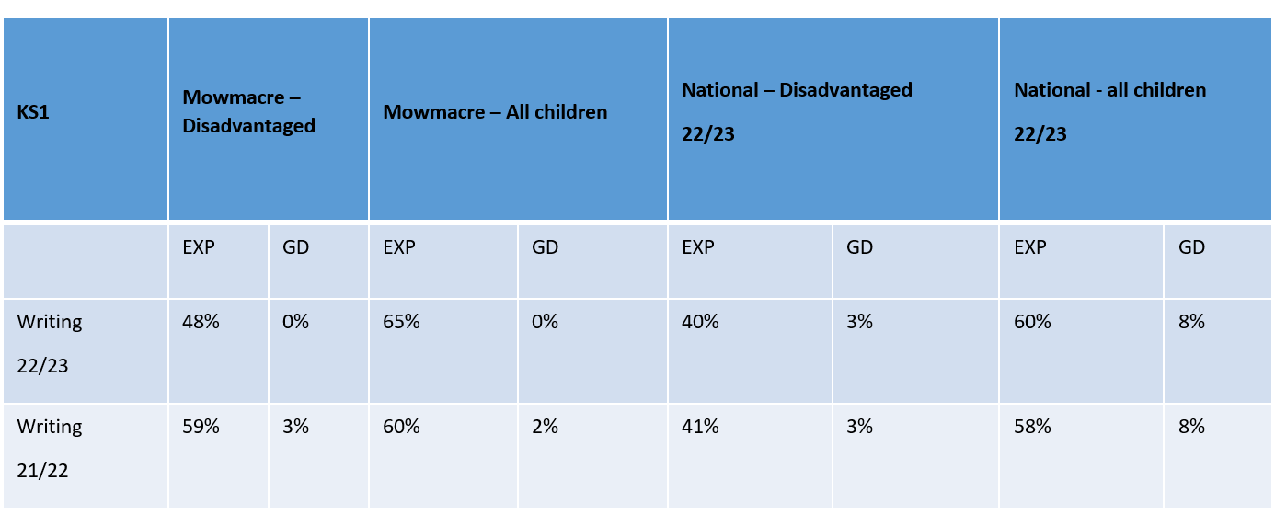
- Mowmacre, KS1 children exceeded the National expectation for both disadvantaged and all children.
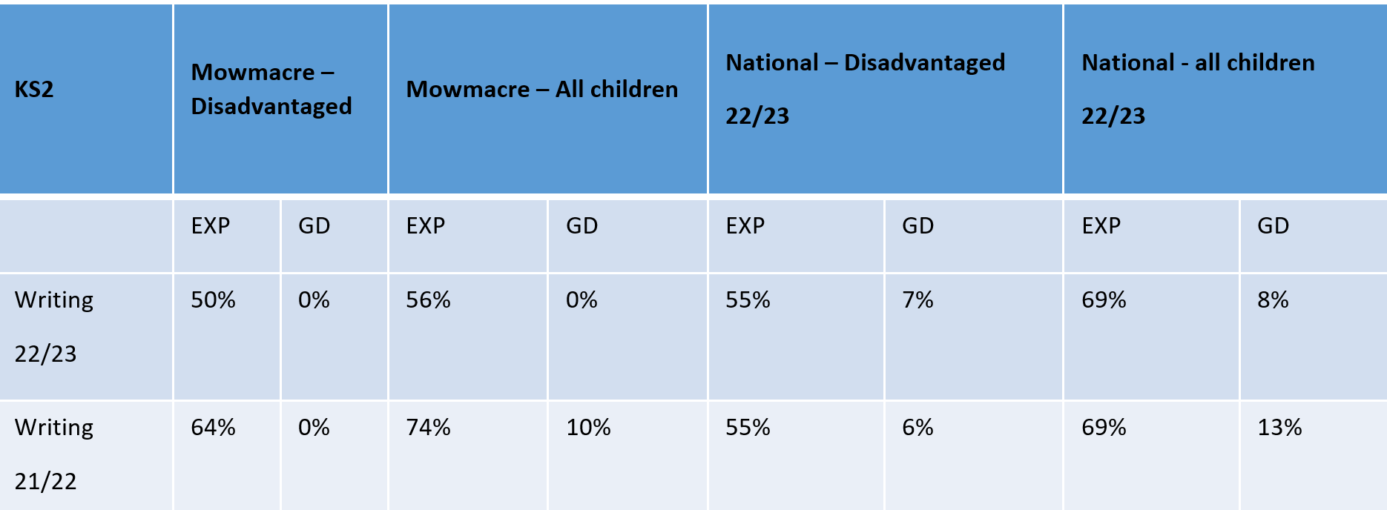
A focus on writing will continue in 23/24. Teacher development release time – each teacher was released for an additional 2 hours per week for coaching and development. This focused time was largely spent on addressing the needs of disadvantaged pupils.
Teachers developed skills using Microsoft Educational Technology and development in this area has led to the school successfully becoming a Microsoft Showcase School. Use of Ed Tech has enabled teachers to target learners more accurately and appropriately such as groups using pre-recorded lessons, academic platforms and use of One Note to access tailored learning.
Real life experiences – we have a bank of case studies covering a breadth of year groups (not saved here due to GDPR).
SEMH support –
- 12 food parcels have been given out so far, this term (September 2023- October 2023)
- 8 parents regularly attend coffee mornings.
- 16 parents signed up to Adult Education courses, including the 8 from coffee mornings.
- Facilitated a number of parenting groups such as ‘The Solihull Approach’, ‘English for Parents stage 1 And 2’, ‘Family Budgeting’, ‘Bumps, Bandaging, Burns and Choking’ and ‘Feed for a Fiver’.
- FSW has supported parents with housing applications, DLA applications, SEN transport, Early Help, in year transfer application and secondary school applications, claim for a new cooker, washing machine and household support fund applications, budgeting advice and food parcels.
- WBT carries out home visits, weekly meeting with local PCO, met with school EWO weekly to discuss children that were CP or social care where attendance was an issue, meet with school nurse.
- Weekly wellbeing meetings with other DSL’S to support vulnerable families and identify others that may need extra support.
- CP conferences (currently 4 cases open), CIN conferences (currently 3 cases open), EH 13 referrals and open to social workers) and 29 individual children on school monitoring that meet a vulnerable criterion.
- Intervention support – Elsa, SEMH support, restorative conversations, Friendship and Social skills.

Attendance
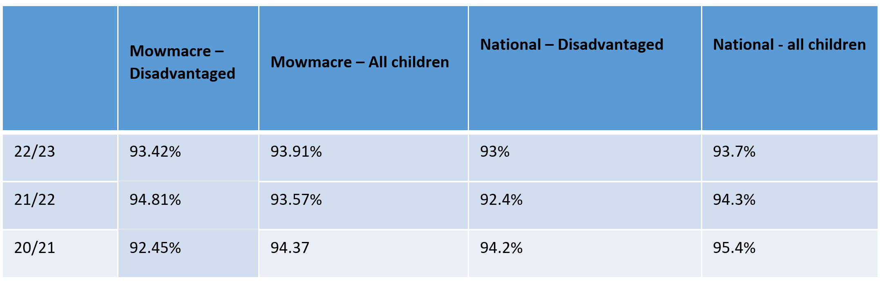
Whilst attendance dropped both nationally and at Mowmacre due to the continuing impact of Covid isolations and other unforeseen circumstances. Mowmacre’s disadvantaged children’s attendance is only slightly below average and all children exceeding the National exceptions. The attendances officers will continue to promote good attendance and work alongside the wellbeing team and Education Welfare Officer (EWO) to ensure that attendance continues to rise throughout the academic year of 2023/2024.

Externally provided programmes
Please include the names of any non-DfE programmes that you used your pupil premium (or recovery premium) to fund in the previous academic year.
Programme | Provider
N/A | N/A
N/A | N/A

Service pupil premium funding (optional)
For schools that receive this funding, you may wish to provide the following information: How our service pupil premium allocation was spent last academic year
N/A
The impact of that spending on service pupil premium eligible pupils
N/A

Further information (optional)
Appendix 1
Case Study
